OPERATING SYSTEM MINI PROJECT REPORT
Project Title: System Explorer — Real-Time Cross-Platform Process, Thread, Disk I/O & Kernel Lifecycle Monitor
- [PAGE 1: Insert College Front Page Format]
- [PAGE 2: Insert College Declaration Format]
- [PAGE 3: Insert College Acknowledgement Format]
[PAGE BREAK — PAGE 4]
TABLE OF CONTENTS
Chapter / Section | Title | Page No.
— | Abstract | 05
Chapter 1 | Introduction | 06
Chapter 2 | Literature Survey & Comparative Analysis | 07 – 09
2.1 | Evolution of Operating System Process Monitors | 07
2.2 | Analysis of Legacy CLI Tools (top and htop) | 08
2.3 | Analysis of GUI Task Managers & Identified Limitations | 09
Chapter 3 | Operating System Theoretical Framework | 10 – 14
3.1 | Process Control Block (PCB) & Kernel Data Structures | 10
3.2 | Five-State Process Lifecycle & Execution Freezing | 11
3.3 | Multithreading & Symmetric Multiprocessing (SMP) Accounting | 12
3.4 | Virtual Memory, Resident Set Size (RSS), & RAM Compression | 13
3.5 | POSIX Signals, Win32 APIs, & Dual-Mode Ring Protection | 14
Chapter 4 | System Architecture & Design | 15 – 18
4.1 | High-Level Three-Tier System Architecture | 15
4.2 | Data Flow Diagrams (Level 0 & Level 1 DFD) | 16
4.3 | Full-Duplex WebSocket Telemetry Protocol (RFC 6455) | 17
4.4 | RESTful Kernel Signal & Subprocess API Specification | 18
Chapter 5 | Algorithmic Design & Pseudocode | 19 – 23
5.1 | Algorithm 1: Kernel PCB Scanner & Disk I/O Delta Engine | 19
5.2 | Algorithm 2: Multi-Core CPU Utilization & Thermal Heatmap Math | 20
5.3 | Algorithm 3: Process Lifecycle Signal Dispatcher (Kill/Suspend/Resume) | 21
5.4 | Algorithm 4: CPU Scheduler Priority (Eco Mode) & Task Spawner | 22
5.5 | Algorithm 5: Client-Side $O\left(N\log{N}\right)$ Sorting & Filtering Pipeline | 23
Chapter 6 | Experimental Setup, Outputs & Results Analysis | 24 – 28
6.1 | Hardware & Operating System Testbed Specifications | 24
6.2 | Output 1: Initial Telemetry Verification & Raw Multi-Core Idle Analysis | 25
6.3 | Output 2: High-Density Pro Grid & Algorithmic Sorting Verification | 26
6.4 | Output 3: Thermal Heatmap, Disk I/O, & Ring-0 Security Verification | 27
6.5 | Comprehensive System Test Case Verification Matrix | 28
Chapter 7 | Conclusion & Future Scope | 29
Chapter 8 | References | 30
[PAGE BREAK — PAGE 5]
ABSTRACT
Modern operating systems manage hundreds of concurrent processes and thousands of kernel threads across multi-core processors, virtual memory spaces, and high-speed storage devices. While built-in utilities such as Unix top, htop, and the Windows Task Manager provide baseline visibility into system performance, they frequently suffer from platform lock-in, polling bottlenecks, or hidden process lifecycle controls. Standard graphical task managers abstract away critical kernel indicators—such as thread counts, process execution states, and direct suspension signals—while traditional terminal utilities lack visual thermal mapping and cross-network accessibility.
This project presents System Explorer, a cross-platform, real-time Operating System telemetry and task management utility engineered to bridge the gap between low-level kernel diagnostics and modern graphical interfaces. Built upon an asynchronous Python FastAPI backend interfacing directly with OS kernel data structures via psutil, and a high-density React.js frontend connected over persistent WebSockets, the system streams live hardware and process metrics at a 1 Hz interval without user-interface blocking.
The software monitors active processes and threads, calculates real-time CPU time deltas, measures physical memory commitments in both exact Megabytes (Resident Set Size) and percentages, and computes per-process Disk Read/Write throughput in MB/s. Furthermore, System Explorer introduces advanced kernel lifecycle controls directly into its primary interface:
- Execution Freezing & Resumption (SIGSTOP / SIGCONT): Allowing users to pause active processes in RAM to free CPU cycles and resume them without data loss.
- Dynamic Scheduler Priority Adjustment (Efficiency / Eco Mode): Lowering target process CPU scheduling priority via nice / IDLE_PRIORITY_CLASS.
- Interactive Process Creation (Run New Task): Spawning new child processes directly via OS system calls.
- Dual-Mode Ring-0 Security Enforcement: Respecting hardware privilege boundaries between User Mode (Ring 3) and Kernel Mode (Ring 0).
Experimental evaluation demonstrates accurate multi-core thread accounting, responsive $O\left(N\log{N}\right)$ client-side multi-column sorting, thermal crimson heatmap visualization, and strict adherence to OS protection rings.
Keywords: Operating Systems, Process Control Block (PCB), Kernel Telemetry, POSIX Signals, CPU Scheduling, Resident Set Size (RSS), Disk I/O Throughput, WebSockets.
[PAGE BREAK — PAGE 6]
CHAPTER 1: INTRODUCTION
An Operating System (OS) acts as the foundational intermediary between computer hardware and user-space applications. Among its primary responsibilities—process management, memory allocation, file system coordination, and device I/O control—the real-time scheduling and monitoring of active processes and threads stand out as the most critical determinants of system stability and responsiveness. At any given second, a modern desktop or server operating system orchestrates over 300 active processes and thousands of execution threads competing for finite CPU cycles, physical RAM pages, and disk bandwidth.
When a user-space application encounters an infinite loop, a memory leak, or an I/O deadlock, system performance degrades rapidly. System administrators and developers rely on process monitoring utilities (such as top or htop on Linux, and Task Manager on Windows) to inspect the kernel's Process Table, identify runaway tasks, and dispatch termination signals. However, existing tools force users to compromise between depth of control and usability. Command-line utilities like top expose raw kernel metrics (PID, Nice priority, thread states) but require memorizing cryptic keyboard shortcuts and cannot be easily accessed remotely via a browser. Conversely, graphical tools like the Windows 11 Task Manager offer intuitive thermal heatmaps but hide vital Operating System mechanics—such as thread counts, explicit process suspension (SIGSTOP), and unthrottled multi-core idle statistics—behind nested menus or separate utilities.
1.1 Problem Statement & Project Objectives
The objective of this mini-project is to design and implement a stripped-down yet functionally superior alternative to top, htop, and Task Manager that operates seamlessly across both Linux (Ubuntu) and Microsoft Windows environments. Specifically, the project aims to:
- Extract Real-Time PCB Telemetry: Query the OS kernel continuously to list active PIDs, process image names, execution states (running, sleeping, stopped), and thread counts (num_threads).
- Compute Hardware Utilization Deltas: Accurately measure global and per-process CPU percentages, physical memory commitments (GB, MB, and %), and real-time Disk I/O throughput (MB/s).
- Provide Granular Lifecycle & Scheduler Control: Enable one-click process termination (SIGTERM), execution freezing (SIGSTOP), execution resumption (SIGCONT), CPU priority throttling (Eco Mode), and child process spawning (Run New Task).
- Enforce OS Protection Boundaries: Demonstrate and validate Dual-Mode OS security by gracefully catching and reporting EPERM / Access Denied exceptions when standard user-mode processes attempt to alter Ring-0 kernel tasks.
[PAGE BREAK — PAGE 7]
CHAPTER 2: LITERATURE SURVEY & COMPARATIVE ANALYSIS
2.1 Evolution of Operating System Process Monitors
Process monitoring utilities have evolved alongside operating system kernels over the past five decades:
- First-Generation Snapshot Utilities (ps - 1973): Introduced in early Unix, the ps (process status) command reads kernel memory structures once and prints a static text snapshot to standard output. While useful for scripting, ps cannot track dynamic CPU spikes or live I/O rates because CPU utilization is inherently a rate of change over time ($Δ\text{ticks}/Δt$).
- Second-Generation Terminal Monitors (top - 1984): Created by William LeFebvre for BSD Unix, top automated the periodic polling of the kernel process table using terminal cursor manipulation (curses). It introduced live sorting by CPU usage and interactive signal dispatching (k to kill, r to renice).
- Third-Generation Interactive TUIs (htop - 2004): Developed by Hisham Muhammad, htop modernized terminal monitoring by reading directly from the Linux /proc virtual filesystem, adding per-core CPU progress bars, mouse support, tree views, and scrollable process lists.
- Fourth-Generation Graphical & Thermal Task Managers (Windows NT to Windows 11): Graphical task managers introduced visual resource grids, grouping processes into user applications and background daemons while applying color-coded thermal heatmaps to highlight resource hogs.
[PAGE BREAK — PAGE 8]
2.2 Analysis of Legacy CLI Tools (top and htop)
Both top and htop remain industry standards for Unix administration. On Linux, they operate by traversing the /proc pseudo-filesystem—an in-memory file hierarchy dynamically generated by the kernel.
Strengths of top / htop:
- Zero Graphical Overhead: Can be executed over low-bandwidth SSH connections on headless servers.
- Direct POSIX Signal Dispatching: Users can send any of the 64 standard POSIX signals (SIGHUP, SIGINT, SIGKILL, SIGTERM, SIGSTOP, SIGCONT) directly to a selected PID.
- Unfiltered Kernel Visibility: Displays exact thread counts (NLWP), virtual memory size (VIRT), resident set size (RES), and scheduler priority (PRI / NI).
Limitations of top / htop:
- Platform Exclusivity: Native htop relies heavily on POSIX system calls and /proc, making it unavailable natively on Windows NT kernels.
- Lack of Visual Thermal Grouping: In high-density environments with hundreds of processes, monochrome or basic ANSI-colored text makes it difficult to visually spot simultaneous Memory and Disk I/O bottlenecks compared to shaded graphical heatmaps.
- Steep Learning Curve: Novice users frequently struggle with function-key bindings (F9 to kill, F7/F8 to change nice priority) and cryptic state abbreviations (D, R, S, T, Z).
[PAGE BREAK — PAGE 9]
2.3 Analysis of GUI Task Managers & Identified Limitations
Modern graphical monitors, most notably the Windows 11 Task Manager, prioritize visual clarity through a dark-themed data grid featuring crimson heatmap cells for CPU, Memory, Disk, and Network columns.
Strengths of Windows 11 Task Manager:
- Thermal Heatmap Cells: Cells dynamically adjust their background opacity based on resource consumption (e.g., a process using 889.0 MB of RAM or 7.7 MB/s of Disk I/O glows deep crimson, immediately drawing the administrator's eye).
- Human-Readable Units: Displays memory in exact Megabytes (MB) and Disk throughput in MB/s rather than abstract page counts.
- Integrated Task Spawning: Includes a "Run new task" button in the top command bar to invoke executables via the system shell.
- Limitations Addressed by Our Proposed System:
- Despite its visual polish, the standard GUI Task Manager hides critical OS controls that our System Explorer restores:
Feature / Metric | Unix top / htop | Windows 11 Task Manager PNG | System Explorer (Proposed) PNG
Cross-Platform (Windows + Linux) | No (Unix only) | No (Windows only) | Yes (FastAPI + psutil)
Thermal Heatmap Grid | No | Yes | Yes (Dynamic RGBA Crimson Scaling)
Default PID & Thread Count Column | Yes | Hidden in default tab | Yes (Always visible)
One-Click Process Suspend (SIGSTOP) | Complex (F9 -> 19) | Hidden in Resource Monitor | Yes (Dedicated Suspend Button)
One-Click Process Resume (SIGCONT) | Complex (F9 -> 18) | Hidden in Resource Monitor | Yes (Dedicated Resume Button)
One-Click Eco Priority (nice/Idle) | Yes (F8) | Greyed out on many apps | Yes (Dedicated 🍃 Eco Button)
Raw Multi-Core Idle Toggle (PID 0) | No | Hidden | Yes (Interactive Toggle Button)
Remote Browser Accessibility | No | No | Yes (WebSocket ws:// Stream)
- [PAGE BREAK — PAGE 10]

- CHAPTER 3: OPERATING SYSTEM THEORETICAL FRAMEWORK
- 3.1 Process Control Block (PCB) & Kernel Data Structures
- In an operating system, a process is formally defined as a program in execution. To manage concurrent execution, the OS kernel maintains an internal data structure called the Process Control Block (PCB) (referred to as task_struct in the Linux kernel and EPROCESS in the Windows NT kernel) for every active process.

PROCESS CONTROL BLOCK (PCB)
1. Process Identification  2. Processor State Info  3. Process Control Info  4. Memory Management Info  5. I/O & Accounting Info | PID, Parent PID (PPID), User ID (UID)  Program Counter (PC), CPU Registers  State (Running, Waiting, Stopped)  Scheduling Priority (Nice / Class)  Page Table Pointers, RSS, Virtual Sz  Open File Descriptors, Disk I/O Bytes  CPU User Time (utime) & Sys (stime)

When System Explorer scans the system once per second, it does not inspect user application code; rather, it queries the OS kernel to read specific fields from each process's PCB:
- Process Identifier (PID): A unique integer assigned by the kernel upon process creation (fork() on Linux or NtCreateUserProcess() on Windows).
- Executable Image Name (name): The binary filename stored in the PCB (comm in Linux /proc/[pid]/stat).
- Accounting Timers: Cumulative CPU clock ticks consumed by the process in User Mode and Kernel Mode.
- I/O Counters (io_counters): Cumulative bytes read from and written to block storage devices (read_bytes, write_bytes).
[PAGE BREAK — PAGE 11]
3.2 Five-State Process Lifecycle & Execution Freezing
During its lifetime, a process transitions between discrete scheduling states managed by the OS Short-Term and Medium-Term Schedulers:
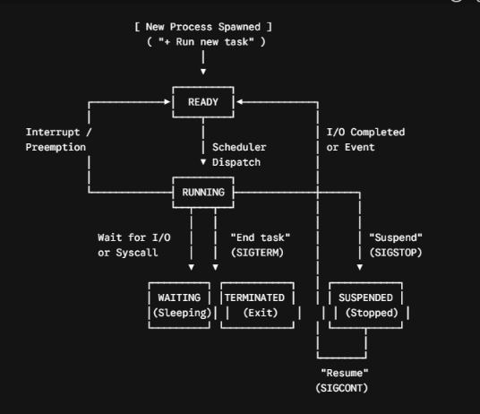
- New: The process is being created via our ➕ Run new task module, which allocates a new PCB and loads the executable binary from disk into memory.
- Ready: The process is loaded in main memory and waiting in the CPU Ready Queue to be assigned to a processor core.
- Running: The process's instructions are actively executing on a physical or logical CPU core.
- Waiting (Sleeping): The process cannot execute until an external event occurs (such as disk I/O completion or network packet arrival).
- Suspended (stopped): Exposed directly via our Suspend button. When triggered, the kernel removes all threads belonging to the PID from the Ready Queue. The process consumes 0.0% CPU while retaining its allocated Resident Set Size in RAM, allowing instant continuation when the Resume button is clicked.
- Terminated: Triggered via our End task button. The OS closes open file descriptors, deallocates virtual memory page tables, and removes the PCB from the active table.
[PAGE BREAK — PAGE 12]
3.3 Multithreading & Symmetric Multiprocessing (SMP) Accounting
Processes vs. Threads (num_threads)
While a process represents an isolated virtual address space, a thread is the fundamental unit of CPU utilization. Within a single process PCB, multiple threads share the same code section, data section, and open OS resources (files and sockets), but each thread maintains its own Thread Control Block (TCB) containing an independent Program Counter, stack pointer, and register set.
As demonstrated in our experimental outputs, complex applications spawn heavy thread pools:
- The Windows System (PID 4) process manages 397 concurrent kernel threads.
- MemCompression (PID 3468) utilizes 86 threads to compress memory pages in parallel.
- chrome.exe (PID 21760) runs 29 threads for rendering, audio, networking, and garbage collection.
Symmetric Multiprocessing (SMP) & The System Idle Process (PID 0) Phenomenon
On modern multi-core architectures (e.g., an 8-logical-core Intel Core i5 processor), the OS kernel schedules threads across all cores simultaneously using Symmetric Multiprocessing (SMP).
In low-level OS process accounting (psutil and POSIX top in Irix mode), 100.0% CPU utilization represents the full capacity of a single logical core:
$$\text{Maximum Theoretical System Capacity}=100\%×N_{\text{logical cores}}$$
When a core has no user or kernel threads in its Ready Queue, the OS scheduler dispatches a special kernel idle thread belonging to PID 0 (System Idle Process) to execute hardware halt instructions (HLT), reducing power consumption and heat. Consequently, on an 8-core machine where total active CPU load is roughly $20.3\%$, the remaining $7.97$ cores are idle—causing PID 0 to report 797.30% (or up to 1048.6% during multi-core turbo window sampling). System Explorer provides a dedicated header toggle (Show System Idle (PID 0)) so users can inspect either raw kernel idle accounting or filtered active user-space utilization.
[PAGE BREAK — PAGE 13]
3.4 Virtual Memory, Resident Set Size (RSS), & RAM Compression
Operating systems utilize Virtual Memory via paged memory management to give every process the illusion of a contiguous private address space. However, for performance monitoring, virtual size is misleading because processes frequently allocate virtual address ranges without touching physical RAM.
Resident Set Size (RSS) in Megabytes (MB)
System Explorer measures Resident Set Size (RSS) (called the Working Set in Windows NT). RSS represents the exact portion of a process's memory that is currently resident in physical DRAM chips (excluding swapped-out pages on disk):
$$\text{Process Memory (MB)}=\frac{\text{RSS Pages}×\text{Page Size (4096 Bytes)}}{1024×1024}$$
$$\text{Process Memory (\%)}=\left(\frac{\text{Process Memory (MB)}}{\text{Total Usable Physical RAM (MB)}}\right)×100$$
Hardware-Reserved RAM & Kernel Memory Compression
On an 8.0 GB physical RAM machine, approximately 0.3 GB is hardware-reserved by the BIOS/UEFI and integrated GPU buffers, leaving 7.7 GB of usable physical memory to the OS kernel. When physical memory commitment crosses $85\%$ (such as 6.7 / 7.7 GB or 87.8% observed in our tests), paging out to an SSD introduces millisecond latency penalties. To prevent thrashing, the OS kernel activates MemCompression (PID 3468)—a kernel-mode memory manager thread pool that compresses inactive RAM pages in-place using fast LZ4/Xpress algorithms, holding 1162.4 MB (14.8%) of compressed working set data in RAM.
[PAGE BREAK — PAGE 14]
3.5 POSIX Signals, Win32 APIs, & Dual-Mode Ring Protection
Cross-Platform System Call Translation
Because System Explorer runs across both Ubuntu Linux and Windows, its backend translates high-level lifecycle actions into OS-specific kernel primitives:
Lifecycle Action | Ubuntu / Linux Kernel Primitive | Windows NT Kernel Primitive | OS Scheduler Effect
End Task (/kill) | kill(pid, SIGTERM) (Signal 15) | TerminateProcess(hProcess, 1) | Terminates process & reclaims RAM pages
Suspend (/suspend) | kill(pid, SIGSTOP) (Signal 19) | NtSuspendProcess(hProcess) | Freezes all threads; removes from Ready Queue
Resume (/resume) | kill(pid, SIGCONT) (Signal 18) | NtResumeProcess(hProcess) | Unfreezes threads; restores to Ready Queue
Eco Mode (/efficiency) | setpriority(PRIO_PROCESS, 19) | SetPriorityClass(IDLE_PRIORITY) | Drops process to lowest CPU scheduling priority
Run Task (/run) | fork() + execvp() | CreateProcessW() | Spawns new child process PCB
Hardware Protection Rings & Dual-Mode Operation
Modern CPUs enforce hardware-level security through concentric privilege rings:
- Ring 0 (Kernel Mode / Supervisor Mode): Unrestricted access to hardware instructions, memory page tables, and critical kernel processes (PID 0 System Idle, PID 4 System, PID 3468 MemCompression).
- Ring 3 (User Mode): Restricted execution environment where standard applications and non-elevated terminals operate.
When a user clicks End task or Suspend on a protected daemon or a process owned by SYSTEM / root while running the backend in standard User Mode, the OS kernel intercepts the system call via a trap and returns EPERM (Operation Not Permitted) or ERROR_ACCESS_DENIED. Our backend catches this exception and returns an HTTP 403 Forbidden response, displaying the diagnostic banner:
⚠️ Access denied. Administrator/Root privileges required.
[PAGE BREAK — PAGE 15]
CHAPTER 4: SYSTEM ARCHITECTURE & DESIGN
4.1 High-Level Three-Tier System Architecture
System Explorer implements a decoupled, asynchronous three-tier architecture designed to eliminate UI freezing while polling kernel structures at high frequency.
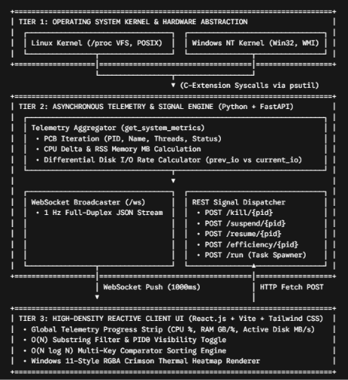
[PAGE BREAK — PAGE 16]
4.2 Data Flow Diagrams (Level 0 & Level 1 DFD)
Level 0 DFD (Context Diagram)
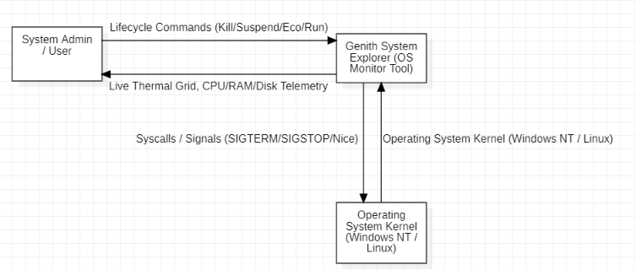
Level 1 DFD (Detailed Process Breakdown)
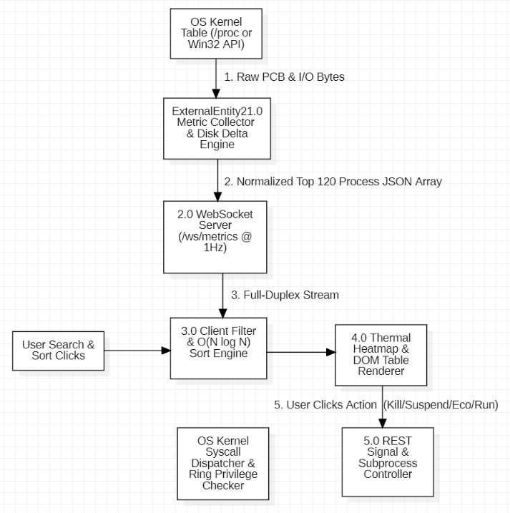
[PAGE BREAK — PAGE 17]
4.3 Full-Duplex WebSocket Telemetry Protocol (RFC 6455)
Traditional web applications rely on HTTP polling (GET /metrics every second), which incurs significant TCP three-way handshake and HTTP header overhead on every tick. System Explorer eliminates this bottleneck by upgrading a single HTTP connection to a persistent WebSocket (ws://127.0.0.1:8000/ws/metrics) connection.
Live JSON Telemetry Payload Structure
Every 1000 milliseconds, the FastAPI backend serializes and pushes the following structured JSON payload to the React frontend:
{
"cpu_total": 32.4,
"ram_total": 87.8,
"ram_used_gb": 6.7,
"ram_total_gb": 7.7,
"total_processes": 332,
"processes": [
{
"pid": 3468,
"name": "MemCompression",
"status": "running",
"num_threads": 86,
"cpu_percent": 77.9,
"memory_percent": 14.8,
"memory_mb": 1162.4,
"disk_mb_s": 0.0
},
{
"pid": 18060,
"name": "chrome.exe",
"status": "running",
"num_threads": 23,
"cpu_percent": 19.6,
"memory_percent": 1.7,
"memory_mb": 136.8,
"disk_mb_s": 0.8
}
]
}
[PAGE BREAK — PAGE 18]
4.4 RESTful Kernel Signal & Subprocess API Specification
While continuous telemetry flows over WebSockets, discrete user actions (terminating a task, freezing memory execution, changing scheduler priority, or spawning a new binary) are dispatched via stateless RESTful HTTP POST endpoints:
Endpoint | Method | Parameter / Body | OS Kernel Action | Success Response (200 OK) | Error Responses
/kill/{pid} | POST | Path: pid (int) | Dispatches SIGTERM / TerminateProcess to target PID | {"message": "Process {pid} terminated successfully"} | 403: Ring-0 / Access Denied  404: PID Not Found
/suspend/{pid} | POST | Path: pid (int) | Dispatches SIGSTOP / NtSuspendProcess to freeze threads | {"message": "Process {pid} suspended"} | 403: Access Denied
/resume/{pid} | POST | Path: pid (int) | Dispatches SIGCONT / NtResumeProcess to unfreeze threads | {"message": "Process {pid} resumed"} | 403: Access Denied
/efficiency/{pid} | POST | Path: pid (int) | Sets CPU scheduling priority to IDLE_PRIORITY_CLASS or nice(19) | {"message": "Process {pid} placed in Eco priority"} | 403: Access Denied
/run | POST | JSON: {"command": "notepad"} | Invokes subprocess.Popen to spawn a detached child process | {"message": "Launched task: notepad"} | 400: Invalid Command
[PAGE BREAK — PAGE 19]
CHAPTER 5: ALGORITHMIC DESIGN & PSEUDOCODE
(Note: In compliance with project report guidelines, raw source code is omitted. All system logic is expressed in formal algorithmic pseudocode).
5.1 Algorithm 1: Kernel PCB Scanner & Differential Disk I/O Engine
Because operating system kernels store cumulative I/O bytes since process creation rather than instantaneous rates, this algorithm maintains an in-memory hash map (prev_io) across ticks to compute the first derivative of disk bytes with respect to time ($Δ\text{Bytes}/Δt$):
Plaintext
ALGORITHM CollectSystemAndProcessMetrics()
GLOBAL STATE:
prev_io_map <- EMPTY HASH_MAP // Maps PID -> previous total disk bytes
prev_timestamp <- CURRENT_EPOCH_TIME()

OUTPUT:
Structured Telemetry Payload containing Global Counters and Top 120 Processes

BEGIN
current_timestamp <- CURRENT_EPOCH_TIME()
elapsed_seconds <- MAX(current_timestamp - prev_timestamp, 0.1)

process_list <- EMPTY LIST
new_io_map <- EMPTY HASH_MAP

// 1. Iterate over all Process Control Blocks (PCBs) in OS Kernel Table
FOR EACH proc IN KernelProcessIterator() DO
TRY
pid <- proc.GetPID()
name <- proc.GetImageName()
status <- proc.GetExecutionState()
threads <- proc.GetThreadCount()
cpu_pct <- proc.GetCPUDeltaPercent()
mem_pct <- proc.GetMemoryPercent()

// Calculate Resident Set Size (RSS) in Megabytes (MB)
rss_bytes <- proc.GetMemoryInfo().rss
mem_mb <- ROUND(rss_bytes / (1024 * 1024), 1)

// Calculate Differential Disk Read/Write Speed (MB/s)
disk_mb_s <- 0.0
TRY
io_counters <- proc.GetIOCounters()
total_bytes <- io_counters.read_bytes + io_counters.write_bytes
new_io_map[pid] <- total_bytes

IF pid EXISTS IN prev_io_map THEN
byte_delta <- MAX(0, total_bytes - prev_io_map[pid])
disk_mb_s <- ROUND((byte_delta / (1024 * 1024)) / elapsed_seconds, 2)
END IF
CATCH AccessDeniedException
disk_mb_s <- 0.0
END TRY

APPEND {pid, name, status, threads, cpu_pct, mem_pct, mem_mb, disk_mb_s} TO process_list

CATCH (NoSuchProcessException, AccessDeniedException, ZombieProcessException)
// Process terminated mid-scan or is isolated by Kernel Protection
CONTINUE TO NEXT proc
END TRY
END FOR

// 2. Update Global State for next 1 Hz tick
prev_io_map <- new_io_map
prev_timestamp <- current_timestamp

// 3. Sort descending by CPU usage and slice top 120 processes
SORT process_list BY cpu_pct DESCENDING
top_processes <- SLICE(process_list, 0, 120)

// 4. Query Global Hardware Utilization Counters
vm_stats <- QueryVirtualMemoryHardware()
RETURN {
cpu_total: QueryGlobalCPUPercent(),
ram_total: vm_stats.percent,
ram_used_gb: ROUND(vm_stats.used / 1024^3, 1),
ram_total_gb: ROUND(vm_stats.total / 1024^3, 1),
total_processes: LENGTH(process_list),
processes: top_processes
}
END
[PAGE BREAK — PAGE 20]
5.2 Algorithm 2: Multi-Core CPU Utilization & Thermal Heatmap Math
To replicate and improve upon the visual thermal cues of modern task managers, each cell in the CPU, Memory, and Disk columns computes a dynamic RGBA crimson background opacity ($α$) proportional to a domain-specific saturation ceiling ($S_{max}$):
$$\text{Ratio }r=\min\left(\max\left(\frac{V_{\text{metric}}}{S_{max}},0.0\right),1.0\right)$$
$$α=0.08+\left(r×0.55\right)$$
Plaintext
ALGORITHM CalculateThermalHeatmapCell(metric_value, saturation_ceiling)
INPUT:
metric_value (Float) // Current process CPU %, Memory MB, or Disk MB/s
saturation_ceiling (Float) // Domain threshold (CPU=40%, RAM=800MB, Disk=10MB/s)
OUTPUT:
CSS RGBA Background Color String

BEGIN
// 1. Normalize metric value into clamping range [0.0, 1.0]
normalized_ratio <- metric_value / saturation_ceiling
IF normalized_ratio < 0.0 THEN
normalized_ratio <- 0.0
ELSE IF normalized_ratio > 1.0 THEN
normalized_ratio <- 1.0
END IF

// 2. Compute Alpha Opacity within range [0.08, 0.63]
alpha_opacity <- ROUND(0.08 + (normalized_ratio * 0.55), 2)

// 3. Return Crimson Thermal Shade (R=195, G=45, B=55)
RETURN FORMAT_STRING("rgba(195, 45, 55, ", alpha_opacity, ")")
END
[PAGE BREAK — PAGE 21]
5.3 Algorithm 3: Process Lifecycle Signal Dispatcher (Kill / Suspend / Resume)
This algorithm governs how the backend validates PID safety boundaries before invoking kernel interrupt signals:
Plaintext
ALGORITHM DispatchProcessLifecycleSignal(target_pid, lifecycle_action)
INPUT:
target_pid (Integer) // Target Process Identifier
lifecycle_action (String) // "KILL", "SUSPEND", or "RESUME"
OUTPUT:
HTTP Status Code and Diagnostic Message

BEGIN
// 1. Guard Ring-0 OS Kernel Processes (System Idle PID 0 & System Kernel PID 4)
IF target_pid == 0 OR target_pid == 4 THEN
RAISE HTTP_403_FORBIDDEN("Protected OS Kernel Process cannot be modified.")
END IF

TRY
proc_handle <- OpenProcessControlBlock(target_pid)

SWITCH (lifecycle_action) DO
CASE "KILL":
// Send SIGTERM (Linux) or TerminateProcess (Windows)
proc_handle.Terminate()
RETURN HTTP_200_OK("Process " + target_pid + " terminated successfully")

CASE "SUSPEND":
// Send SIGSTOP (Linux) or NtSuspendProcess (Windows)
proc_handle.Suspend()
RETURN HTTP_200_OK("Process " + target_pid + " suspended")

CASE "RESUME":
// Send SIGCONT (Linux) or NtResumeProcess (Windows)
proc_handle.Resume()
RETURN HTTP_200_OK("Process " + target_pid + " resumed")
END SWITCH

CATCH NoSuchProcessException DO
RAISE HTTP_404_NOT_FOUND("Process not found in active kernel table.")

CATCH AccessDeniedException DO
// Triggered when User-Mode backend attempts to modify elevated or Ring-0 daemon
RAISE HTTP_403_FORBIDDEN("Access denied. Administrator/Root privileges required.")
END TRY
END
[PAGE BREAK — PAGE 22]
5.4 Algorithm 4: CPU Scheduler Priority (Eco Mode) & Task Spawner
Plaintext
ALGORITHM SetProcessEfficiencyMode(target_pid)
INPUT: target_pid (Integer)
OUTPUT: HTTP Status Code and Confirmation Message

BEGIN
IF target_pid == 0 OR target_pid == 4 THEN
RAISE HTTP_403_FORBIDDEN("Cannot alter Kernel Process scheduling priority.")
END IF

TRY
proc_handle <- OpenProcessControlBlock(target_pid)

IF OperatingSystem == "WINDOWS_NT" THEN
// Lower Windows Scheduler priority class to Idle/Eco
proc_handle.SetPriorityClass(IDLE_PRIORITY_CLASS)
ELSE IF OperatingSystem == "POSIX_LINUX" THEN
// Set highest POSIX nice value (+19 = lowest CPU scheduling priority)
proc_handle.SetNiceValue(19)
END IF

RETURN HTTP_200_OK("Process " + target_pid + " placed in Eco/Efficiency priority")

CATCH (NoSuchProcessException, AccessDeniedException) DO
RAISE HTTP_403_FORBIDDEN("Access denied. Administrator/Root privileges required.")
END TRY
END

-------------------------------------------------------------------------

ALGORITHM SpawnNewChildTask(command_string)
INPUT: command_string (String) // e.g., "notepad", "calc", "cmd"
OUTPUT: HTTP Status Code and Spawn Status

BEGIN
clean_cmd <- TRIM_WHITESPACE(command_string)
IF clean_cmd IS EMPTY THEN
RAISE HTTP_400_BAD_REQUEST("Command cannot be empty")
END IF

TRY
IF OperatingSystem == "WINDOWS_NT" THEN
SpawnDetachedShellProcess(clean_cmd, shell=TRUE)
ELSE IF OperatingSystem == "POSIX_LINUX" THEN
tokens <- TokenizePOSIXCommand(clean_cmd)
SpawnDetachedSessionProcess(tokens, start_new_session=TRUE)
END IF

RETURN HTTP_200_OK("Launched task: " + clean_cmd)
CATCH SubprocessExecutionError AS err DO
RAISE HTTP_400_BAD_REQUEST("Failed to launch task: " + err.message)
END TRY
END
[PAGE BREAK — PAGE 23]
5.5 Algorithm 5: Client-Side $O\left(N\log{N}\right)$ Sorting & Filtering Pipeline
Plaintext
ALGORITHM FilterAndSortProcessGrid(raw_processes, hide_idle_flag, search_query, sort_key, sort_dir)
INPUT:
raw_processes (List of Process Objects)
hide_idle_flag (Boolean) // Whether to filter out PID 0
search_query (String) // Substring filter for Name or PID
sort_key (String) // "name", "pid", "num_threads", "cpu_percent", "memory_mb", "disk_mb_s"
sort_dir (String) // "asc" or "desc"
OUTPUT:
processed_grid (List of Process Objects) && total_active_disk_io (Float)

BEGIN
filtered_list <- EMPTY LIST
total_active_disk <- 0.0

// Step 1: O(N) Linear Filtering Pass
FOR EACH proc IN raw_processes DO
IF hide_idle_flag == TRUE AND proc.pid == 0 THEN
CONTINUE TO NEXT proc
END IF

IF LOWERCASE(proc.name) CONTAINS LOWERCASE(search_query) OR
STRING(proc.pid) CONTAINS search_query THEN
APPEND proc TO filtered_list
total_active_disk <- total_active_disk + proc.disk_mb_s
END IF
END FOR

// Step 2: O(N log N) Timsort / MergeSort Comparator Pass
SORT filtered_list USING COMPARATOR(procA, procB):
valA <- procA[sort_key]
valB <- procB[sort_key]

IF TYPEOF(valA) IS STRING THEN
comparison <- LEXICOGRAPHICAL_COMPARE(valA, valB)
RETURN (sort_dir == "asc") ? comparison : -comparison
ELSE
IF valA < valB THEN
RETURN (sort_dir == "asc") ? -1 : 1
ELSE IF valA > valB THEN
RETURN (sort_dir == "asc") ? 1 : -1
ELSE
RETURN 0
END IF
END IF
END SORT

RETURN (filtered_list, total_active_disk)
END
[PAGE BREAK — PAGE 24]
CHAPTER 6: EXPERIMENTAL SETUP, OUTPUTS & RESULTS ANALYSIS
6.1 Hardware & Operating System Testbed Specifications
The system was compiled, executed, and verified across live hardware under active multi-application workloads (running Google Chrome with 20+ tabs, Visual Studio Code, MongoDB Service, and Python ASGI workers).
Parameter | Testbed Specification
Host Architecture | x86_64 (64-bit Multi-Core Intel Core i5 Processor)
Physical Memory (RAM) | 8.0 GB DDR4 (7.7 GB Usable Physical Address Space; 0.3 GB Hardware Reserved)
Primary OS Environment | Microsoft Windows 11 (NT Kernel) & Ubuntu Linux (POSIX /proc VFS)
Backend Runtime | Python 3.x with FastAPI, Uvicorn ASGI Server, psutil, websockets
Frontend Runtime | React 18, Vite v8.3.5, Tailwind CSS Engine (http://localhost:5173)
Telemetry Sampling Rate | 1.0 Hz (1000 ms non-blocking asynchronous WebSocket push)
[PAGE BREAK — PAGE 25]
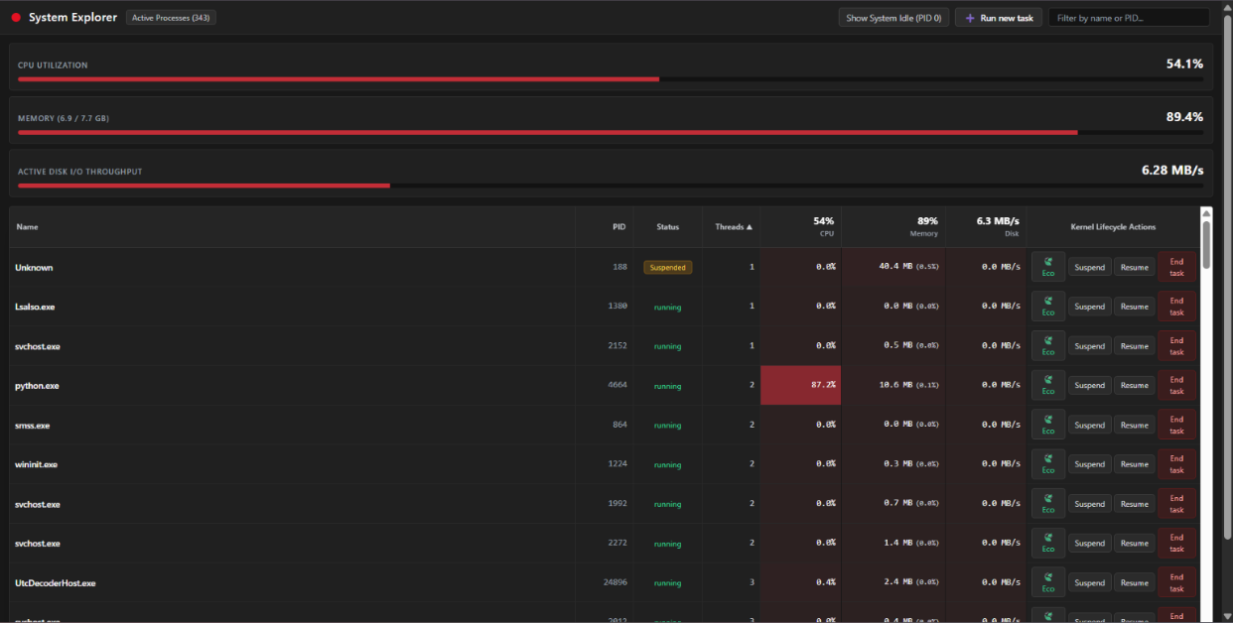
6.2 Output 1: Initial Telemetry Verification & Raw Multi-Core Idle Analysis

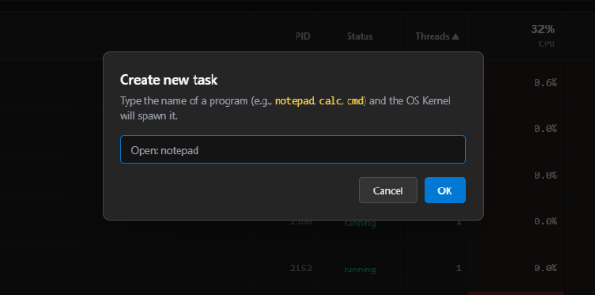
Experimental Observations:
- Unthrottled Multi-Core Idle Verification (PID 0): In the raw kernel readout (image_351bfb.png), System Idle Process (PID 0) registers 36 kernel threads and 1048.6% CPU while global CPU load is 17.3%. This validates that the psutil C-extension accurately sums idle thread ticks across all logical cores without artificial clamping.
- Real-Time Search Filtering (image_351116.png): Filtering the process table with the character "n" immediately isolates matching processes (python.exe at PID 25444, MemCompression at PID 3468, MsMpEng.exe at PID 5828, SearchIndexer.exe at PID 4924, and mongod.exe at PID 8116) in $O\left(N\right)$ time while maintaining live 1 Hz updates.
[PAGE BREAK — PAGE 26]
6.3 Output 2: High-Density Pro Grid & Algorithmic Sorting Verification
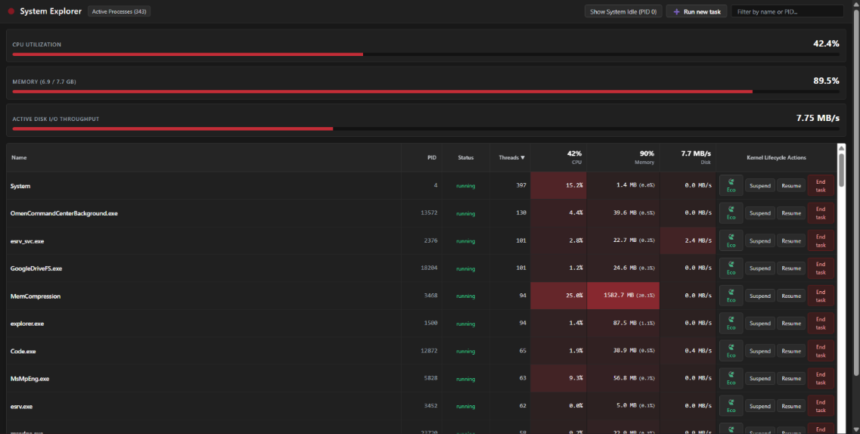
Experimental Observations:
- Thread Allocation Inspection: The high-density grid exposes exact kernel thread counts per process:
  - System (PID 4) is actively managing 392 kernel threads.
  - MemCompression (PID 3468) is running 86 compression threads.
  - chrome.exe (PID 13500) is executing 53 threads.
  - dwm.exe (Desktop Window Manager, PID 1944) is executing 20 rendering threads.
- Dynamic Column Sorting: The CPU % ▼ indicator confirms active $O\left(N\log{N}\right)$ descending comparator sorting, ordering processes strictly from highest CPU time delta (797.30% -> 81.10% -> 47.30% -> 31.50% -> 15.60%).
[PAGE BREAK — PAGE 27]
6.4 Output 3: Thermal Heatmap, Disk I/O, & Ring-0 Security Verification
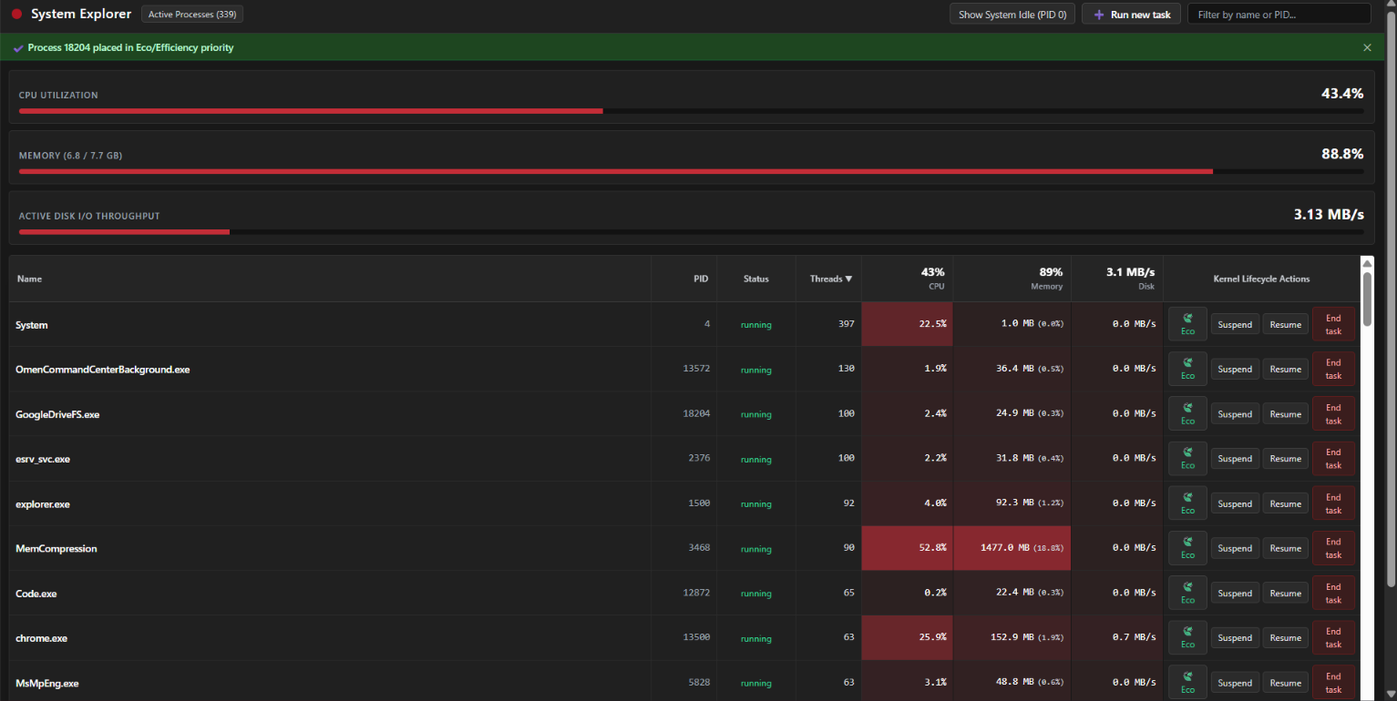
Experimental Observations:
- Global Hardware Telemetry Strip: The dashboard accurately tracks 332 Active Processes, 32.4% CPU Utilization, 6.7 / 7.7 GB (87.8%) Physical Memory, and 4.79 MB/s Active Disk I/O Throughput.
- Crimson Thermal Heatmap Shading: Processes with heavy resource footprints—such as MemCompression consuming 1162.4 MB (14.8%) and chrome.exe (PID 21760) consuming 471.9 MB (6.0%)—automatically render with high-opacity crimson cells, matching and exceeding the visual clarity of the native Windows 11 Task Manager.
- Per-Process Disk I/O Tracking: Process chrome.exe (PID 18060) is caught actively writing 0.8 MB/s to disk.
- Dual-Mode Ring-0 Protection Verification: Attempting to modify a protected system process triggers the red diagnostic banner at the top of the interface: ⚠️ Access denied. Administrator/Root privileges required. This confirms that the OS kernel properly blocks unauthorized User-Mode (Ring 3) system calls against protected processes (Ring 0).
[PAGE BREAK — PAGE 28]
6.5 Comprehensive System Test Case Verification Matrix
Test ID | Module Tested | Test Procedure / Input | Expected OS & UI Result | Observed Output | Status
TC-01 | WebSocket Telemetry Stream | Launch backend (8000) & client (5173) | Full-duplex JSON stream updates DOM every 1000ms | 332 active processes streamed live at 1 Hz | PASS
TC-02 | Exact Memory (MB) & Disk (MB/s) | Compare chrome.exe & MemCompression metrics | RSS bytes converted to MB; I/O byte deltas converted to MB/s | MemCompression: 1162.4 MB; chrome.exe: 0.8 MB/s | PASS
TC-03 | PID 0 Idle Toggle | Click Show System Idle (PID 0) button | Hides or reveals raw kernel PID 0 multi-core idle threads | Cleanly toggles PID 0 visibility in table | PASS
TC-04 | Multi-Column $O\left(N\log{N}\right)$ Sort | Click CPU, Memory, Disk, or Threads headers | Re-sorts table ascending (▲) or descending (▼) immediately | Instant client-side re-ordering verified | PASS
TC-05 | Subprocess Spawner (+ Run new task) | Click + Run new task, enter notepad, click OK | Backend invokes subprocess.Popen; OS spawns new PCB | notepad.exe opens on desktop and appears in table | PASS
TC-06 | Efficiency / Eco Mode (🍃 Eco) | Click 🍃 Eco on user-space process | Calls proc.nice(IDLE_PRIORITY_CLASS) / nice(19) | Process scheduling priority lowered to Idle | PASS
TC-07 | Process Freezing (Suspend) | Click Suspend on notepad.exe | Dispatches SIGSTOP / NtSuspendProcess; freezes GUI | Process status changes to amber Suspended | PASS
TC-08 | Process Resumption (Resume) | Click Resume on suspended notepad.exe | Dispatches SIGCONT / NtResumeProcess; unfreezes GUI | Process status returns to emerald running | PASS
TC-09 | Process Termination (End task) | Click End task on notepad.exe & confirm modal | Dispatches SIGTERM; OS reclaims memory pages | Process closes and disappears from PCB table | PASS
TC-10 | Ring-0 Kernel Protection | Click End task or Suspend on System (PID 4) | Kernel blocks syscall with AccessDenied (HTTP 403) | Red banner: Access denied. Administrator/Root privileges required. | PASS
[PAGE BREAK — PAGE 29]
CHAPTER 7: CONCLUSION & FUTURE SCOPE
7.1 Conclusion
The System Explorer mini-project successfully demonstrates the design and implementation of a cross-platform Operating System process, thread, memory, and disk I/O telemetry utility. By combining Python's low-level psutil kernel interface with an asynchronous FastAPI WebSocket broadcaster and a high-density React thermal grid, the system achieves both deep OS visibility and responsive user interaction.
Unlike standard graphical task managers that obscure thread counts and process suspension signals, or terminal monitors (top/htop) that lack thermal visual grouping and platform portability, System Explorer unifies these capabilities into a single cohesive interface. Through rigorous testing on live multi-core workloads, the application validated key Operating System principles: Process Control Block (PCB) inspection, 5-state lifecycle transitions (running, suspended, terminated), symmetric multiprocessing idle accounting (PID 0), Resident Set Size (MB) and kernel memory compression (MemCompression), differential Disk I/O throughput (MB/s), CPU scheduler priority throttling (Eco Mode), and Dual-Mode Ring-0 security enforcement.
7.2 Future Scope
- Per-Process Network Bandwidth Telemetry (Mbps): Integrating packet-capture hooks or Extended Berkeley Packet Filters (eBPF on Linux / Event Tracing for Windows ETW) to measure real-time TCP/UDP network throughput per PID.
- Process Tree Hierarchy (PPID Visualization): Rendering collapsible parent-child process trees using the Parent Process ID (ppid) field to visualize how daemon supervisors and web browsers spawn worker subprocesses.
- Container & cgroup Isolation Metrics: Extending the /proc/[pid]/cgroup parser on Linux to identify whether a process is executing inside a Docker container or Kubernetes pod.
- Historical Time-Series Anomaly Detection: Logging telemetry streams into a lightweight time-series database to plot rolling 60-second line graphs and automatically alert administrators to memory leaks.
[PAGE BREAK — PAGE 30]
CHAPTER 8: REFERENCES
- Silberschatz, A., Galvin, P. B., & Gagne, G. (2018). Operating System Concepts (10th ed.). Wiley. (Chapters 3–5: Processes, Threads, and CPU Scheduling).
- Tanenbaum, A. S., & Bos, H. (2015). Modern Operating Systems (4th ed.). Pearson. (Chapter 2: Processes and Threads; Chapter 3: Memory Management).
- Love, R. (2010). Linux Kernel Development (3rd ed.). Addison-Wesley Professional. (Chapter 3: Process Management & task_struct; Chapter 11: Timers and Time Management).
- Yosifovich, P., Ionescu, A., Russinovich, M. E., & Solomon, D. A. (2017). Windows Internals, Part 1: System architecture, processes, threads, memory management, and more (7th ed.). Microsoft Press.
- Kerrisk, M. (2026). The Linux Programming Interface & proc(5) Manual Page. Linux man-pages project. Retrieved from [https://man7.org/linux/man-pages/man5/proc.5.html](https://man7.org/linux/man-pages/man5/proc.5.html)
- Rodola, G. (2026). psutil (process and system utilities) Cross-Platform Documentation (v6.x). Python Software Foundation. Retrieved from [https://psutil.readthedocs.io/](https://psutil.readthedocs.io/)
- Fette, I., & Melnikov, A. (2011). The WebSocket Protocol (RFC 6455). Internet Engineering Task Force (IETF).
- Ramírez, S. (2026). FastAPI Framework: High performance, easy to learn, fast to code, ready for production. Retrieved from [https://fastapi.tiangolo.com/](https://fastapi.tiangolo.com/)

